Home Learning – Learning Base 2 - wk bg – 1st and 8th May 2023
English
This week the children will be looking at
Pobble picture – Transport in Bangladesh
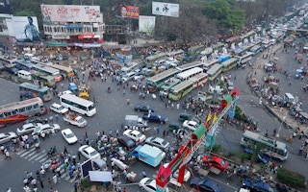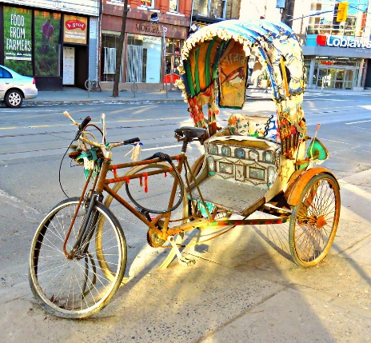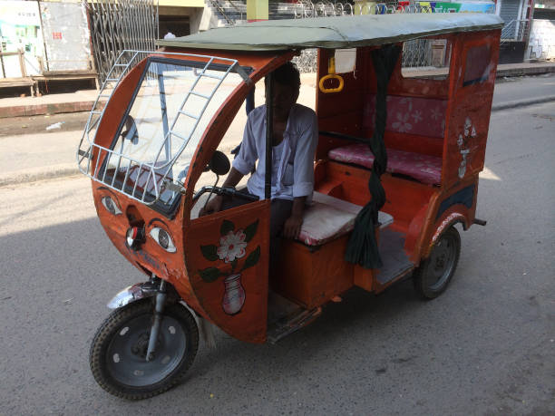

Parents
- Talk to your child about ‘All the different transport seen in Bangladesh’
- Have you seen a bust road like the picture in Bangladesh?
- Does the transport look familiar to transport in England?
- What is the man driving?

Look at the Key word and Phonic list that is for your child (individual words to learn)
These are the sounds and words that your child is learning in class at the moment
Look at and use the Precision teaching activity with your child

Parents
- read the list
- say the word in context eg- red. The apples are red.
- say each word and if needed, say the sounds in the words
- encourage your child to write the word
- Precision teaching – play with the words and then do the daily 1 minute reading from the sheet

 Do 5 exercises daily
- https://teachhandwriting.co.uk/handwriting-warm-up-exercises.html
Please practice your child’s full name so that all the letters are formed correctly.
Please use the Letters and sounds (alphabet) sheet.
Say the letter formation as you write the letter eg. “round them astronauts helmet and into space” when writing the letter /a/.
Say the letter and sound of the letters in your child’s name. Form the letter correctly.
Parents
- Do this every day for the correct formation of all the letters of the alphabet
THIS will be updated to the new handwriting scheme shortly
Please read your child’s reading book at home.
Talk to them about what is happening in their book
Write words from their book for your child to write

Parents
– Please read the books everyday
- PLEASE write in your child’s yellow book to inform Mrs.Sullivan-Boardman

Maths
EVERY week, your child in the Learning base will be accessing Maths learning at their own level of development.
THIS week the children will be concentrating on shapes in the environment
Parents
- Look at hidden shapes around your house. Can you see anything that is a circle, square or triangle shape?
- What objects have you got that are different shapes?
- Help your child by talking about the different shapes.
- What shape is a tin of beans, box of cereal, orange?
- Do this with a variety of shapes. Describe the shapes.

TOPIC – Transport
Your child will be learning about the different Transport in the different countries that we have already studied – Pakistan, Bangladesh, England, China and India.
During Literacy, they are looking at ‘The different transport in Bangladesh’.
Please watch the videos and talk about what you notice

Videos –
https://www.youtube.com/watch?v=e8zEKRIugoU
https://www.youtube.com/watch?v=oWmeLJaSwvI
https://www.youtube.com/watch?v=GfC58MgiauQ – rickshaw

Parents
- Talk about and describe what you notice
- Create in different ways
- THROUGHOUT the half term, please concentrate and make
Drawing. Painting, Collage, Junk modelling of different forms of transport
Curriculum – Music
The music service have added lessons online. Go to https://www.GMmusiconline.co.uk/yumu
Enter your username and password in the boxes on the screen.
Your username is: p1351527
Your password is: symphony
Click on the different tabs to listen to the songs that your children take part in

Don’t forget-
info@greenhill.theharmonytrust.org OR Add to your child’s seesaw account
Reminders
PLEASE could you also ‘Seesaw’ to send photos or videos of what your child is learning and doing at home.

Purplemash homework – use your log in details

