Home Learning – Learning Base 2 - wk bg – 9th and 15th May 2023
English
This week the children will be looking at
Pobble picture – Transport in Bangladesh
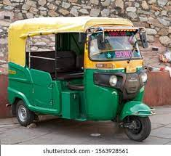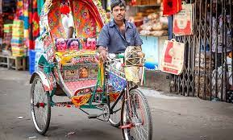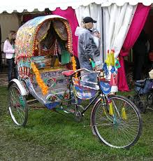
Parents
- Talk to your child about ‘All the different transport seen in Bangladesh’
- Have they seen anything like that before? Where?
- Does the transport look familiar to transport in England?
- Have you been on any of these transport in Bangladesh?
Look at the Key word and Phonic list that is for your child (individual words to learn)
These are the sounds and words that your child is learning in class at the moment
Look at and use the Precision teaching activity with your child

Parents
- read the list
- say the word in context eg- red. The apples are red.
- say each word and if needed, say the sounds in the words
- encourage your child to write the word
- Precision teaching – play with the words and then do the daily 1 minute reading from the sheet

 Do 5 exercises daily
- https://teachhandwriting.co.uk/handwriting-warm-up-exercises.html
Please practice your child’s full name so that all the letters are formed correctly.
Please use the Letters and sounds (alphabet) sheet.
Say the letter formation as you write the letter eg. “round them astronauts helmet and into space” when writing the letter /a/.
Say the letter and sound of the letters in your child’s name. Form the letter correctly.
Parents
- Do this every day for the correct formation of all the letters of the alphabet
THIS will be updated to the new handwriting scheme shortly

Please read your child’s reading book at home.
Talk to them about what is happening in their book
Write words from their book for your child to write

Parents
– Please read the books everyday
- PLEASE write in your child’s yellow book to inform Mrs.Sullivan-Boardman

Maths
EVERY week, your child in the Learning base will be accessing Maths learning at their own level of development.
THIS week the children will be concentrating on Numeral recognition and the quantities for each numeral. The children will also be adding 2 digit numbers.
Parents
- Look at individual numerals, say the number and count out the correct amount of objects
- Help your child to visualise the problem by drawing the calculation
- DO THIS EVERYDAY with different numbers and items

TOPIC – Transport
Your child will be learning about the different Transport in the different countries that we have already studied – Pakistan, Bangladesh, England, China and India.
During Literacy, they are looking at ‘The different transport in Bangladesh’.
Please watch the videos and talk about what you notice

Parents
- Talk about what you notice
- Describe
- Create in different ways
- THROUGHOUT the half term, please concentrate and make
Drawing. Painting, Collage, Junk modelling of different forms of transport
Curriculum – Music
The music service have added lessons online. Go to https://www.GMmusiconline.co.uk/yumu
Enter your username and password in the boxes on the screen.
Your username is: p1351527
Your password is: symphony
Click on the different tabs to listen to the songs that your children take part in
Science – FROGS
The children have been looking at the frogspawn that was collected from Mrs.Sullivan-Boardman’s pond. They watched a video to show what will happen to the frogspawn over 7 weeks.
https://www.youtube.com/watch?v=wAcwjWi6I9Y
https://www.youtube.com/watch?v=etGmCvIL014

Parents
- Please watch the video and let your children talk about it

Don’t forget-
info@greenhill.theharmonytrust.org OR Add to your child’s seesaw account
Reminders
PLEASE could you also ‘Seesaw’ to send photos or videos of what your child is learning and doing at home.

Purplemash homework – use your log in details

