Home Learning Year 4- WB: 29th March 2021
English |  | Completed by...
Spelling/Phonics: | Spellings - Common exception words  Play the game- Against the Clock  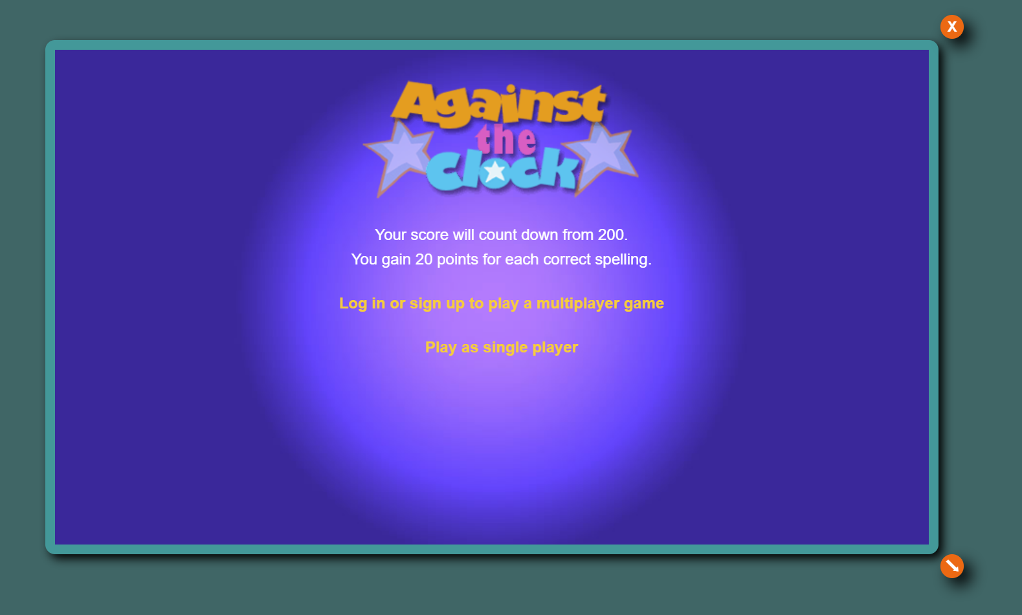  Spelling games: Common exception words (spellzone.com) | 5/04/21
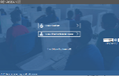  Reading: | Remember to read your reading book at home and visit myON and Accelerated Reader to read a range of books and complete quizzes online    myON  This week please can you complete the reading task:  Read on a selection of books for our Science Topic - Animals Including Humans.    Accelerated Reader  https://ukhosted13.renlearn.co.uk/6013217/ | Ongoing  5/04/21
Writing: | - Write a recount of your sports trip to Alexander Park  - Login to myON and complete the Animals Including Humans project | 5/04/21
Maths:
  Maths | Purple mash: Numbers over 1000, compare and order  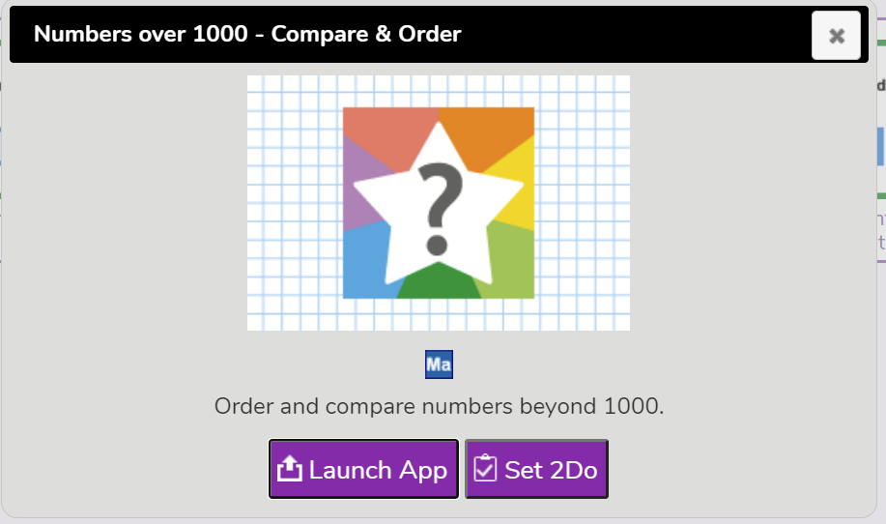  TT Rockstars:  Login to your TT Rockstars account and complete your weekly timetables challenge!  Remember to spend 10 minutes daily on TT rockstars!    Can you beat your best score and will you be getting closer to the green zone? | 5/04/21  Ongoing
Curriculum
One curriculum area to be selected a week | Login to Purple Mash and….  Complete the activity Layers of the rainforest. Watch the video by clicking the link below to help you.  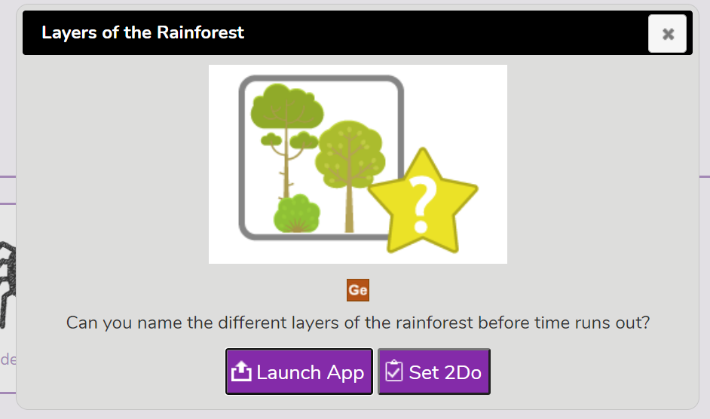  The Layers of the Rainforest #readalong - Bing video | 5/04/21
On-going project- | Research information about the Rainforest. Remember, you can use books from the library or the internet for help. Alternatively, you could create a fantastic piece of art work based on the Rainforest | Ongoing
Don’t forget- we love seeing your home learning. You can always take a photo and email to school or tweet us! We are looking forward to seeing what you have been up to.

